

CAPSTONE PROJECT REPORT
Report 5 – Software Test Documentation

– Ho Chi Minh, October 2026 –
Table of Contents
I. Record of Changes 3
II. Testing Documentation 4
1. Scope of Testing 4
Features and Functions to Be Tested 4
2. Test Strategy 9
2.1 Testing Types 9
2.2 Test Levels 10
2.3 Supporting Tools 10
3. Test Plan 11
3.1 Human Resources 11
3.2 Test Environment 11
3.3 Test Milestones 12
4. Test Cases 12
5. Test Reports 12

I. Record of Changes
Date | A*  M, D | In charge | Change Description
15/10/2026 | A | Nguyễn Thành Trung | 2.1 Testing Types  2.2 Test Levels  2.3 Supporting Tools  3.1 Human Resources  3.2 Test Environment  3.3 Test Milestones
29/10/2026 | A | Nguyễn Thành Trung | 1. Scope of Testing
30/10/2026 | M | Nguyễn Thành Trung | 1. Scope of Testing
30/10/2026 | A | Nguyễn Thành Trung | 4. Test Cases (Unit test)  5. Test Reports (Unit test)
*A - Added M - Modified D - Deleted

II. Testing Documentation

1. Scope of Testing

Features and Functions to Be Tested
- Core Features: Authentication, Event Management, Runner Registration & Payment, QR Code Check-in, Race Results Management, Photo Management, Race Coordination, Event Staff Management
- Admin Features: Platform Administration.
Feature | Function | Role | Description
Authentication | Register | Guest | Validate email, username password length 8–100, full name, phone, and date of birth. A verified or locked email is rejected. An unverified email can register again and receive a new OTP.
Authentication | Verify email | Guest | Submit the email OTP and activate the account. A wrong or expired OTP is rejected. Login stays blocked until this succeeds.
Authentication | Resend OTP | Guest | Send a new verification OTP for an account that is not active yet.
Authentication | Login | Guest | Sign in with username and password and return an access token valid for 8 hours. Wrong username and wrong password share one error. A locked account and an unverified email are rejected separately.
Authentication | Forgot Password | Guest | Send a reset OTP to the account email.
Authentication | Change Password | Authenticated User | Require the current password, then store a new password of 8–100 characters. A wrong current password is rejected.
Authentication | Update profile | Authenticated User | Read and update name, phone, date of birth, gender, ID or passport, and avatar. Avatar upload stores the file and updates the profile.
Authentication | Logout | Authenticated User | Clear the token stored in the browser and return to the home page. The token stops being accepted when the 8-hour lifetime ends.
Event Management | Browse events | Guest | List approved or registration-open events, open one event, and load its public distances and package catalog.
Event Management | Create event | Organizer | Create a draft with license information and distances.
Event Management | Edit event profile | Organizer | Update a draft or rejected event: profile, banner or permit file, distances and ticket prices, and the BIB range of each distance.
Event Management | Buy event package | Organizer | Create a package order in pending payment, open its details, or cancel it while it is unpaid. Payment continues in the payment functions.
Event Management | Submit event | Organizer | Send a draft or rejected event to the admin review queue.
Event Management | Open or close registration | Organizer | Open runner registration only after admin approval. Close it again while it is open.
Event Management | File event complaint | Organizer | Send a complaint for an event joined in the last month, then read the list and the organizer reply.
Event Management | Reply to complaint | Organizer | Reply and mark the complaint accepted or rejected.
Runner Registration & Payment | Create registration | Runner | Register for an open distance. The registration starts as pending payment. A health-certificate upload returns a file URL stored on the registration.
Runner Registration & Payment | View or cancel registration | Runner | List and open your own registrations. Cancel is allowed only while payment is still pending. A confirmed ticket shows BIB and QR payload.
Runner Registration & Payment | Resubmit registration | Runner | After a paid registration is rejected, edit the profile and return it to pending approval without paying again.
Runner Registration & Payment | Review registration | Organizer | List registrations of the event. Approve confirms the runner and assigns a BIB when none was sent. Reject stores the rejection.
Runner Registration & Payment | Pay registration | Runner | Create a PayOS link for a pending registration. A live pending link is reused. After return, sync reads PayOS: PAID moves the registration to pending approval. The owner can cancel a pending payment.  (PayOS webhook: PayOS PAID calls the same confirm path as sync. An unknown order is acknowledged so PayOS accepts the URL.
Runner Registration & Payment | Pay event package | Organizer | Create a PayOS link for a package order, with the same expiry and reuse rules as registration checkout.
Runner Registration & Payment | Request refund | Runner | Request a refund from the amount already paid and the refund policy percent, not from the current distance price.
QR Code Check-in | Load check-in desk | Volunteer | Load events where the user is active staff, or events they organize, and list confirmed runners with check-in state.
QR Code Check-in | Check in runner | Volunteer | Check in by BIB or by the QR payload on the ticket. Volunteer scanner, coordinator scanner, and the user scan page call the same API.
QR Code Check-in | Sync offline check-in | Volunteer | When the scan page is offline it keeps the check-in on the device and posts the same request after the network returns.
Race Results Management | Record start, finish | Volunteer, Coordinator, ,Organizer | Record a start for a bib and a distance.  Record a finish for a bib and a distance.
Race Results Management | View leaderboard | Guest, Runner | Open the public leaderboard of one distance, with paging and a gender filter. The signed-in runner can also open their own results.
Race Results Management | Download certificate data | Runner | For a finished registration owned by the caller, return name, event, bib, distance, time, and pace. The screen builds the PDF. An unfinished or invalid result returns false with HTTP 200.
Photo Management | Upload photos | Photographer | Bulk-upload files for an event where the caller is an active photographer. New photos stay pending.
Photo Management | Run OCR | Photographer | Enqueue pending or failed photos. The page polls the queue. The OCR worker claims queued photos; the page does not call the worker.
Photo Management | Correct BIB | Photographer | Change the BIB only when the photo is Needs Review or Runner Reported. The photo becomes Manually Corrected.
Photo Management | Publish photos | Photographer | Publish matched or manually corrected photos so a runner search can find them. A photo that cannot be published is skipped.
Photo Management | Discard photo | Photographer | Reject a photo that needs review, pending, or failed.
Photo Management | Search photos by BIB | Runner | Search published photos for one event and BIB. No match returns HTTP 200 and an empty list.
Photo Management | Download photo | Runner | Open or download a searchable photo through the API.
Photo Management | Dispute photo | Runner | Report one photo with a reason. The photo becomes Runner Reported and a dispute opens.
Photo Management | Review photo dispute | Photographer | List open disputes. Approve sends the photo back to review. Reject stores the reason.
Race Coordination | Edit course | Organizer | Geocode a place in Vietnam, save the route of a distance, and see which distances already have a route.
Race Coordination | View course | Coordinator | Open the saved route of the assigned event.
Race Coordination | Manage supplies | Organizer | List, add, replace, and delete aid-station items. Quantity is in cartons.
Event Staff Management | Add staff | Organizer | Add coordinator, photographer, or volunteer account and be active immediately without otp verify.
Event Staff Management | Assign station | Organizer | Set the checkpoint, aid point, or task of a member.
Event Staff Management | Remove staff | Organizer | Remove a member from the event.
Event Staff Management | View my assignments | Volunteer, Coordinator, Photographer | List events where the signed-in user is an active staff member.
Platform Administration | Manage users | Admin | List and open users. Create, update, lock, unlock, reset password, or delete an account.
Platform Administration | Approve event | Admin | Open the pending queue and a non-public event. Approve does not open registration. Reject requires a reason.
Platform Administration | Manage promo codes | Admin | Create and update a code, including active flag, expiry, and maximum uses.
Platform Administration | Manage packages | Admin | Create and update package duration (name, months, price) and capacity (name, max runners, add-on fee).
Platform Administration | Set platform fees | Admin | Read and update the platform fee, withdrawal percent, and refund cap.
Platform Administration | Read audit log | Admin | Page through the audit list. Entries are append-only.

2. Test Strategy

2.1 Testing Types

Test Type | Objective | Technique | Completion Criteria
Functional Testing | Verify system functions align with requirements | Requirement-based test cases; Positive/negative testing; Boundary value analysis | All functional cases executed; No critical defects open
Unit Testing | Validate individual code units in isolation | xUnit + NSubstitute; White-box testing; Mock external dependencies | Code coverage 70%; 100% tests pass
Integration Testing | Verify component interactions | Manual API testing via Swagger/Postman; Data flow validation | API response 3s; Data consistency 100%; No 5xx errors
UI/UX Testing | Ensure interface consistency and usability | Manual cross-browser testing (Chrome, Edge); Responsive verification | No broken layouts; Intuitive navigation; All elements render correctly
Security Testing | Validate authentication and data protection | RBAC verification; SQL injection/XSS attempts; File upload security | No unauthorized access; Secure file handling; Validated JWT implementation
Acceptance Testing | Confirm system meets business requirements | End-to-end workflows with stakeholders; Real-world scenario validation | Stakeholder approval; All critical use cases validated

2.2 Test Levels

Type of Tests | Test Level
Type of Tests | Unit | Integration | System | Acceptance
Functional Testing | X | X | X | X
Unit Testing | X
UI/UX Testing |  |  | X | X
Security Testing | X | X | X
Integration Testing |  | X

2.3 Supporting Tools

Purpose | Tool | Vendor/In-house | Version
Unit Testing | xUnit | .NET Foundation | 2.9.3
Mocking | NSubstitute | NSubstitute | 5.3.0
Coverage | Coverlet collector | Open source | 6.0.4
API Testing | Swagger UI (Swashbuckle) | Open Source | 10.0.1
Database | PostgreSQL | PostgreSQL Global Development Group | 18
Bug Tracking | Jira | Atlassian | Latest
Test Management | Google Sheets | In-house | Latest

3. Test Plan

3.1 Human Resources

Worker/Doer | Role | Specific Responsibilities/Comments
Trần Huy Hoàng | Leader | Overall planning, test review, distributing test tasks to team members.  Write test case and execute test
Nguyễn Thành Trung | Member | Write test case and execute test
Võ Trường Phú | Member | Write test case and execute test
Tôn Thành Vinh | Member | Write test case and execute test
Phạm Tiến Dũng | Member | Write test case and execute test

3.2 Test Environment

Purpose | Tool | Provider | Version
Development | Localhost | Developer | .NET 10
Staging Server | VPS Ubuntu 22.04 | Vietnix | None
Database | PostgreSQL | PostgreSQL Global Development Group | 18
File Storage | Cloudflare R2 Storage | Cloudflare | AWSSDK.S3 3.7.416.12
Payment Gateway | PayOS Sandbox | PayOS | None
Client Browser | Chrome/Edge | Local | None

3.3 Test Milestones

Milestone Task | Start Date | End Date
Phase 1: Unit Testing Setup & Core Modules | Week 7 | Week 7
Phase 2: Feature Testing | Week 8 | Week 8
Phase 3: Integration & Payment Testing | Week 9 | Week 9
Phase 4: System Testing & Security Validation | Week 10 | Week 10
Phase 5: UAT & Final Stabilization | Week 11 | Week 11

4. Test Cases
- Unit Test Cases:
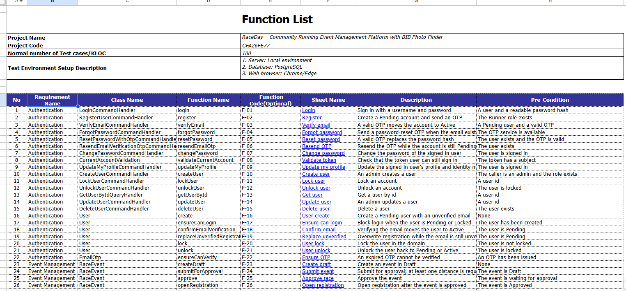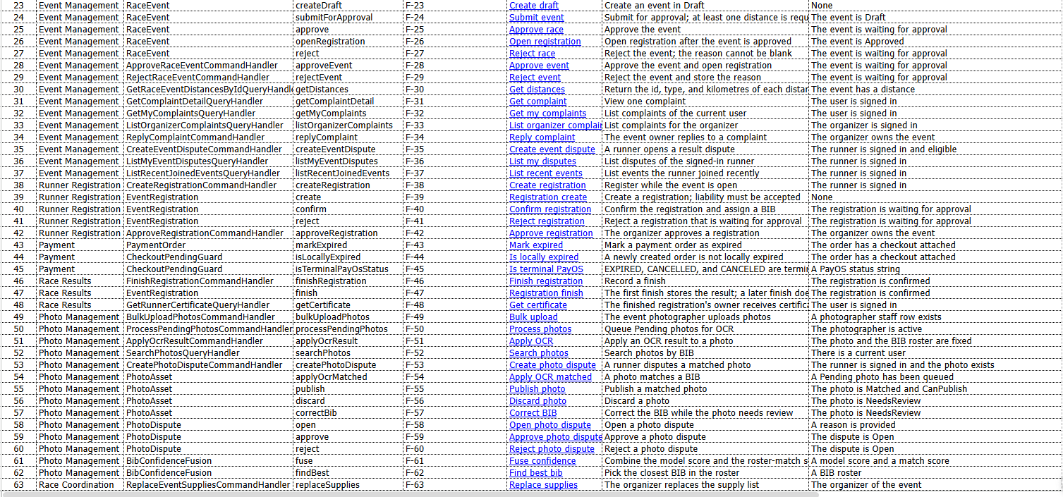
- Other Test Cases (IT, ST, AT):

5. Test Reports
- Unit Test Report:
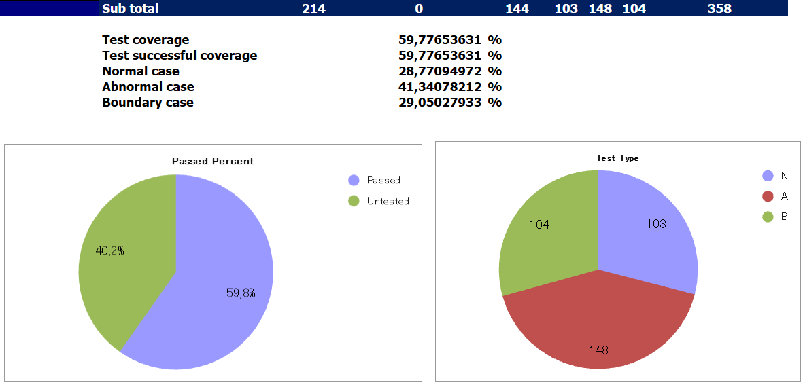
- Integration Test Report:

